Bonus Project Report

Part A: Data Construction

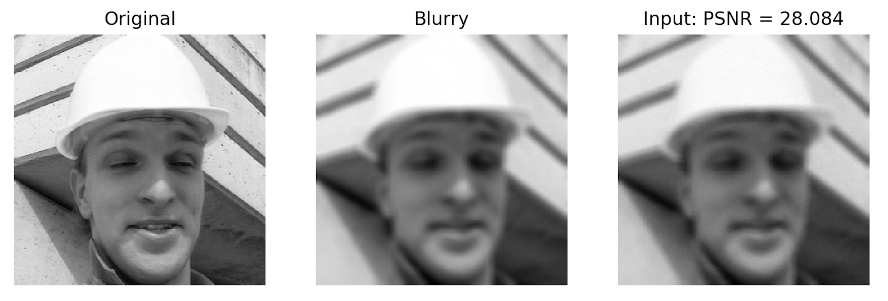

Insert PSNR value of final degraded image: 28.084

Part B: Deblurring via Regularization by Denoising (RED)

RED reconstructed image:

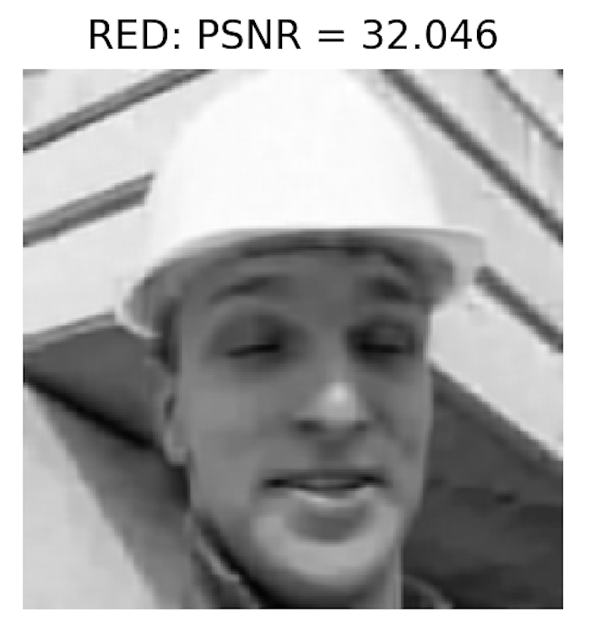

Enter PSNR of reconstruction: 32.046

Discuss the obtained results below:

RED is able to deblur the corrupted image, and we can visually observe the improvement. Also RED is able to improve PSNR which indicates a reduction of noise.

PSNR as a function of FP iterations:



Discuss the obtained results below:

As the iteration proceeds, better PSNR can be achieved; furthermore, the algorithm is not stopping, meaning if the algorithm iterates longer, a still better PSNR can be obtained thus a higher-quality deblurred image.